Macrosystems EDDIE:

Cross-Scale Interactions

**Instructor’s Manual**

# Module Description

Environmental phenomena are often driven by multiple factors that interact across space and over time. In freshwater lakes and reservoirs worldwide, phytoplankton blooms are increasing in frequency and severity due to interactions between local, regional, and continental drivers, including land use (local) and climate change (regional) drivers. In this module, students will learn how to set up a lake model and "force" the model with climate and land use scenarios to test hypotheses about how local and regional drivers interact to promote or suppress phytoplankton blooms in different lakes. The overarching goal of this module is for students to explore new modeling and computing tools while learning fundamental concepts about how non-linear macrosystem-level phenomena (e.g., lake phytoplankton blooms) can occur through cross-scale interactions.

# Pedagogical Connections

|  |  |  |
| --- | --- | --- |
| **Phase** | **Functions** | **Examples from this module** |
| Engagement | Introduce topic, gauge students’ preconceptions, call up students’ schemata | Short introductory lecture |
| Exploration | Engage students in inquiry, scientific discourse, evidence-based reasoning | Development of hypotheses of how climate change and land use affect lakes; testing of these hypotheses by forcing lake models with climate and land use scenarios to see how the lakes respond |
| Explanation | Engage students in scientific discourse, evidence-based reasoning | In-class discussion of the effects of the different climate and land use scenarios |
| Expansion | Broaden students’ schemata to account for more observations | Assessing cross-scale interactions by comparing combined climate + land use scenarios to separate climate and land use model output; comparing how multiple lakes respond to the same scenarios |
| Evaluation | Evaluate students’ understanding, using formative and summative assessments | In-class discussion of how climate change and land use change can affect phytoplankton blooms in lakes |

# Learning Objectives

By the end of this module, students will be able to:

* Understand the concepts of macrosystems ecology and cross-scale interactions, and how different ecological processes can interact at local, regional, and continental scales.
* Simulate phytoplankton blooms in multiple lakes using ecosystem models of lake water quality set up with publicly-available high-frequency sensor datasets (Activity A).
* Test the effects of a climate scenario on the different lake models, and examine how the timing and intensity of phytoplankton blooms change with climate warming (Activity B).
* Examine the effects of both local nutrient loading and regional climate forcing to determine how factors acting at different scales interact to affect the intensity and timing of phytoplankton blooms (Activity C).
* Predict how lake phytoplankton blooms may respond globally to changing climate and land use.

# How to Use this Module

This entire module can be completed in one 3-4 hour lab period or three 60-minute lecture periods for senior undergraduate students or graduate students. Activities A and B could be completed with upper level students in two 60-minute lecture periods, with Activity C as a separate add-on activity. We found that teaching this module in one longer lab section with short breaks was more conducive for introductory students than multiple 1-hour lecture periods.

Quick overview of the activities in this module

* Activity A: Explore and run a lake water quality model in R
* Activity B: Select a climate scenario, generate hypotheses, and examine how different lakes respond
* Activity C: Model the effects of climate and land use change scenarios on multiple lakes, and make predictions about continental-scale phytoplankton blooms

In this module, we have developed pre-made scenarios for both climate and land use based on future conditions derived from downscaled climate scenarios. For each lake, there are three pre-made climate scenarios and three pre-made land use scenarios, for a total of nine potential scenario combinations. We encourage instructors to have different teams of students complete different scenario combinations to compare and contrast their model output.

Pre-made scenario files for each lake are named as follows:

**Climate:** Each scenario represents a year-round increase in air temperatures (+2°C, +4°C, or +6°C) relative to baseline historical conditions.

1. met_hourly_plus2.csv
2. met_hourly_plus4.csv
3. met_hourly_plus6.csv

**Land Use:** Each scenario represents a year-round increase in phosphorus inputs to surface waters (2x, 4x, or 6x) relative to observed concentrations. These scenarios represent degrees of intensification of agriculture and/or urban/suburban land use in the watershed.

1. inflow_twoP.csv
2. inflow_fourP.csv
3. Inflow_sixP.csv

# Module Workflow

1. Have students install R and RStudio software on their laptops before class (send them the Module 2 "R You Ready for EDDIE" file for step-by-step directions).
2. Give students their handout ahead of time to read over prior to class, or distribute handouts when they arrive to class. We recommend having students read pages 1-3 before class as homework, and that instructors print out pages 4-7 to have students complete during the module.
3. Instructor gives brief PowerPoint presentation on how macrosystems ecology can be used to understand cross-scale interactions, using the example of how climate and land use change can affect phytoplankton blooms in lakes. PowerPoint also includes an overview of the GLM-AED model that will be used in the module.
4. After the presentation, the students divide into teams (two pairs of students per team), set up the GLM files and R packages on their computer to run a lake model and explore the output (Activity A).
5. The instructor then introduces Activity B, where students select and run one of the pre-made climate scenarios.
6. The students create hypotheses about how their air temperature scenario may affect their lakes, force the lakes with their climate scenario, and analyze the output between the lakes to determine how their scenario alters lake phytoplankton blooms (Activity B).
7. The instructor then introduces Activity C, where students select and run one of the pre-made land use scenarios.
8. The students create hypotheses about how their scenario’s change in phosphorus loading may affect their lakes, then force the lakes with their scenario. Students then model their combined climate and land use change scenarios to examine cross-scale interactions in their lakes.
9. Teams of students put together figures from their model output to present their model simulations and results to the rest of the class, with the instructor moderating the discussion (Activity C).

**Important Note to Instructors:**

The R packages used in this module are continually being updated, so these module instructions will periodically change to account for changes in the code. If you find any errors or have other feedback about this module, please contact the module developers (see “We’d love your feedback” below).

**We encourage instructors to read through and run the R code before teaching the module so that you are familiar with all of the steps of this activity.**

# Things to do prior to starting the instructor’s presentation

* Make sure that all students have downloaded R and RStudio successfully on their laptops (see “R You Ready for EDDIE?” file for step-by-step directions).
* While checking to make sure that everyone has R downloaded, have students that are ready and waiting type in some basic commands into the R interface (e.g., ‘2+2’) to explore its capabilities.
* Organize student pairs by operating system, such that Windows PC users are working together, and OS X Macintosh users are working together. It also helps for students to work with partners that have the same version of operating system (e.g., El Capitan vs. Yosemite vs. Sierra Mac OS users; Windows 7 vs. Windows 10 PC users), though it’s not necessary.
* Have the students read through the student handout, especially the “Why macrosystems ecology?” and “Today’s focal question” sections.

# Introductory PowerPoint Presentation

*Note: the numbers below match the PowerPoint slide numbers. The text for each slide is also in the “Notes” of the PowerPoint, so can be viewed when projecting in Presenter View.*

1. TITLE SLIDE

Welcome the students to class. It might be helpful to go around the room and briefly discuss if anyone has experience programming or modeling. The point of this is to emphasize that most students are likely novices, and that asking lots of questions is ok because their peers are novices as well.

It is really important at this point to emphasize that there will be lots of new material covered during this module, and that going slowly and asking for help is very much encouraged!

We generally try to organize the classroom so that students with similar operating systems (e.g., Mac vs PC) can work together; this module asks students to work in pairs and share data among a team of two pairs each.

2. OVERVIEW OF TODAY

Quick road map of what will be covered in the PowerPoint

3. PHYTOPLANKTON BLOOMS INCREASING GLOBALLY

Why do we want to know about how phytoplankton blooms in lakes? Has anyone ever seen a surface scum of phytoplankton on a lake before?

4. WHAT ARE THE DRIVERS OF THESE BLOOMS?

Today, we are going to focus specifically on the timing and intensity of phytoplankton blooms in different lakes. The two major drivers of blooms in most lakes are land use change and warming climate. The tricky thing is that while land use change and climate warming are occurring globally, they are not occurring in the same way for all lakes: some lakes may be experiencing more warming (or even cooling!) and other lakes may be experiencing more severe land use change than others. Consequently, we need new ways to think about how these two drivers may interact at different temporal and spatial scales to affect water quality in lakes.

5. USING A MACROSYSTEMS ECOLOGY APPROACH TO STUDY PHYTOPLANKTON BLOOMS

Drivers of phytoplankton blooms occur at both local and regional scales: e.g., the temperature and nutrient concentrations of inflowing streams and groundwater are local factors, whereas weather/climate patterns tend to be regional.

Looking at the effects of drivers operating at multiple scales uses a macrosystems ecology approach, which entails studying ecological dynamics and feedbacks across multiple spatial and temporal scales.

Here, we are using a macrosystems approach combining high-frequency sensor data and simulation models to compare the effects of local and regional drivers on lake phytoplankton blooms.

6. CROSS-SCALE INTERACTIONS: WHAT ARE NON-LINEAR RESPONSES?

Ask students if anyone can describe what cross-scale interactions are, or if they can give an example.

The part to emphasize here is that when drivers that occur at different scales interact, they can result in non-linear responses, where the change in an output we observe is not always proportional to the change we observed in the input. This can make cross-scale interactions seem unpredictable or counterintuitive.

We note that not all cross-scale interactions are non-linear, but many are, which makes studying cross-scale interactions important for understanding ecosystem responses to climate and land use change.

7. Cross-scale interactions: Example

A non-ecological example of a cross-scale interaction could be when trying to predict a corn farmer's income for a year. Local weather and global crop markets operate a very different spatial and temporal scales, but they interact across these scales to affect farmer income.

Trying to predict a farmer's income a priori from just local or global drivers alone would be very difficult.

8. CROSS-SCALE INTERACTIONS IN LAKES

Phytoplankton blooms can be an example of cross-scale interactions in lakes: we know that climate and nutrients contribute to blooms, but the importance of these drivers on bloom formation varies among lakes substantially. Some lakes may be exhibiting blooms due to land use change, some lakes may be exhibiting blooms due to climate change, and some lakes may be exhibiting blooms due to the interaction between both land use (a local factor) and climate change (a regional factor) occurring simultaneously.

9. OUR FOCAL QUESTION

Today, we are going to focus specifically on how changes in land use and climate interact at local and regional scales to affect water quality, specifically, the timing and intensity of phytoplankton blooms. We are going to model different lakes, and see if cross-scale interactions of blooms occur in multiple lakes experiencing climate and land use change simultaneously.

10. MODELS TO UNDERSTAND MULTIPLE DRIVERS

To study the effects of climate and land use change on lakes, researchers use models, because it is impossible to manipulate factors such as solar radiation, air temperatures, and inflowing stream nutrients on real-world lakes at the whole-lake scale in a controlled way.

However, simulation modeling allows us to test how changes in one or more drivers alters lake chlorophyll-a concentrations. Simulation models allow us to manipulate weather and land use change in a computer, and test the effects of lots of modeling experiments. For example, an experiment could be if air temperatures increased by 2°C.

11. GLM: GENERAL LAKE MODEL

The simulation model we are going to use is GLM (the General Lake Model), which was developed in 2012 as an open-source model by researchers in GLEON, the Global Lakes Ecological Observatory Network.

GLM gives us the opportunity to do climate change experiments, in which we modify different climate conditions and study their effects on the lake.

12. GLM SCHEMATIC

GLM is a lake physics model, which uses climate forcing data as input (e.g., high-frequency inflows, snow, wind, temperature, humidity, radiation) and models lake thermal structure, with lake temperatures as output.

13. AED: AQUATIC ECODYNAMICS

GLM has a water quality module called Aquatic EcoDynamics (AED) that we will use today to model water chemistry and biology dynamics in lakes. We couple GLM and AED to simulate water quality.

We will be using AED to look at how chlorophyll-a concentrations change in the lake over time and under different climate and land use scenarios. Chlorophyll a is a proxy for phytoplankton biomass.

14. BASIC STRUCTURE OF THE MODEL

GLM requires a separate new folder/directory on each student’s laptop, which will be downloaded as an RStudio project.

Within this folder will be:

1. a CSV (comma-separated values) file, which has the climate driver data (also referred to as a ‘met’ file; or a file with the meteorological data. We call this ‘met_hourly.CSV’),
2. one or more .nml files, which can be opened as a text file, and act as a master script to the GLM and AED models (they contain parameters for how the model should work, tell the model basic info on the lake, such as depth, latitude, time period of the simulation, etc.), and
3. inflow/outflow CSV files that specify the temperature, flow rate, and nutrient concentrations of the connected streams entering and leaving the lake.

15. EXAMPLE MET FILE

Here is an example met file, with columns for time step, shortwave radiation, longwave radiation, air temperature, relative humidity, wind speed, rain, and snow.

This met file is on an hourly time step.

For our climate change scenarios today, we will change the daily AirTemp by either 2, 4, or 6 degrees year-round, to see how changes in air temperature affect lake water temperatures. These scenarios are based on real climate warming projections between now and the year 2099 for the focal lakes.

Note to instructors: to examine other meteorological variables, we encourage you to check out Macrosystems EDDIE module #1 (Climate change effects on lake temperatures), which involves manipulating many variables simultaneously in which students design their own climate scenarios.

Note the DateTime structure of the time column: GLM requires this exact format of YYYY-MM-DD hh:mm:ss. GLM also requires that the column headers are spelled exactly like what is in this file (and are capitalization-specific). If this file is opened in Excel, it will corrupt the GLM timestamp.

16. EXAMPLE NML FILE

Here is an example .nml file, which goes through many required pieces of information, such as what the name of the lake being modeled is, its latitude/longitude, the time period being modeled, etc. You can open up an .nml file in a text editor program to make changes.

Fun fact: nml stands for “namelist” in the Fortran programming language.

17. EXAMPLE INFLOW FILE

Here is an example inflow file, with columns for time step, water volume (FLOW), salt concentration, water temperature, and a number of columns for different types of nitrogen and phosphorus. This inflow file is on a daily time step.

For our land use change scenarios today, we’ll ONLY be changing the PHS_frp column, which represents the type of phosphorus that phytoplankton take up. The reason why we are focusing on phosphorus is because it is the limiting nutrient for phytoplankton in many lakes and also can increase in response to land use, especially increased sedimentation due to deforestation.

18. WE WILL RUN GLM-AED USING R

We are going to run GLM in R, a programming language and statistical environment that is used for running statistics, making figures, and doing lots of different analyses.

Within R, you can download lots of different software ‘packages’ for different types of analyses.

The benefit to R is that it is free, runs on all operating systems, and is reproducible- i.e., any code that you write can be saved and run later, and you know exactly what you did!

R is the preferred programming language of many ecologists and provides a great entry level language for learning some basic coding skills that are used in many different career paths.

19. LAKES WE’RE GOING TO MODEL TODAY

For today’s module, we’ll be comparing two REAL lakes that differ in their trophic state. Lake Sunapee is oligotrophic, with low nitrogen and phosphorus concentrations in the water, while Lake Mendota is eutrophic, with high nitrogen and phosphorus.

The two lakes also differ in the types of land use that dominate their watersheds; Sunapee is primarily forested, with limited areas of urban development and agriculture. In contrast, Mendota’s watershed is dominated by agriculture and urban development, with very limited forest.

Both lakes are members of the Global Lakes Ecological Observatory Network (GLEON), a grassroots organization of lake scientists, computer scientists, engineers and citizen scientists committed to sharing data and documenting change in water quality around the world. The data that we’ll be analyzing was graciously shared from GLEON researchers.

20. LEARNING OBJECTIVES

Learning objectives!

Talk through these with the students one by one: use the embedded animations to sequentially show each of the bullet points.

Most importantly, the goal here is to have students develop their own hypotheses for how climate and land use interact to affect different lakes, and then test their hypotheses by forcing the lakes with the climate and land use scenarios.

They will then make mini-presentations to share their findings with the class as part of Activity C.

A major goal is to compare how the lakes with different baseline water quality respond to the same climate change and land use change scenarios, and to see if cross-scale interactions occur– i.e., do both lakes respond to changes in drivers in the same way? Which driver is each lake most sensitive to? Let’s find out!

21. WORKFLOW OF THE MODULE

Divide the students into teams of 4 students with 2 pairs each. In Activity A, one pair will model Mendota and one pair will model Sunapee using the baseline (observed) data.

In Activity B, the four students will work together to test a climate scenario, which one pair will apply to Mendota and the other will apply to Sunapee and compare how the phytoplankton respond in both lakes relative to the baseline conditions.

In Activity C, the four students will work together to test a land use scenario, which one pair will apply to Mendota and the other will apply to Sunapee. They can then compare all four possibilities of land use and climate change to determine a) in which scenario are phytoplankton blooms greatest, b) how the two lakes respond to the same forcing conditions, and c) if there are cross-scale interactions apparent in the lakes.

We encourage instructors to have their student teams choose different pairs of land use/climate change scenarios so that they can compare the strength of cross-scale interactions for their model output.

22. DISCUSSION QUESTIONS EMBEDDED IN YOUR HANDOUT

On your handout, there are questions for each section of the module. As you work through the module, be sure you’re writing down answers to each of the questions, as you’ll be turning these worksheets in at the end of class! Note to instructors: these could also be collected as homework, depending on the class’ experience level and which activities you plan to cover.

23. ACTIVITY A

Introduce Activity A, which has 2 objectives divided among 5 tasks.

* Download R packages and GLM files onto your computer and explore configuration files
* Run the GLM model and explore the baseline model output for a lake.

Have students work in pairs as described earlier.

After you’ve introduced the steps of Activity A, stop the PowerPoint and let the students get started on Activity A.

# Activity A: Plot water temperature and chlorophyll-a in your model lakes

Activity A challenges the students to create a plot of lake temperatures and chlorophyll-a concentrations in a lake, using real, high-frequency climate forcing data and inflow files. Ask the students to open the module R script. Before you let them work independently in their pairs, open the R script on your computer and project it to show them how to run lines of code, and also what lines of code correspond to Activity A.

**Important: Tell the students to read through the detailed annotation corresponding to each line of code before they run the code in R. The most important part of this module is understanding what the code is doing, which is provided in the annotation in extensive detail.** The annotation is the text that follows a line of code behind the # sign.

## Common stumbling blocks for Activity A include:

* If students have used RStudio before, they may have a lot of files open by default when they load RStudio. We recommend having students close all open files, except for the CSI_R_Script.R file before they begin.
* If students have not unzipped the ‘cross_scale_interactions’ folder on their Desktop and opened the R script directly from the zipped folder, they will get error messages when trying to set their sim_folder and working directory during Objective 1. If this is the case, they will need to close RStudio, unzip the ‘cross_scale_interactions’ folder, and open the CSI_R_Script.R from the ***un***zipped folder.
* In Objective 1, students may not know how to find their model lake folder path, which is needed to set the sim_folder. The R script has a placeholder sim_folder that students will need to edit to match their computer- if they downloaded the ‘cross_scale_interactions’ folder to the Desktop, they will need to change their computer name and their lake name. (e.g., sim_folder <- '/Users/**ComputerName**/Desktop/cross_scale_interactions/**LakeName'**). They can find their folder path by following these steps:
  + Navigate to the ‘cross_scale_interactions’ folder on the Desktop. Right click on the folder that matches the lake they want to model, then select **Properties** (Windows) or **Get Info** (Mac), then look under Location (Windows) or Where (Mac). Students will need to change their computer name in the R script folder path. They can find their computer name after Users (examples below):
    - **Windows**: C:/Users/***KJF***/Desktop/ cross_scale_interactions /***Mendota***
      * Here, the computer name is KJF, LakeName is Mendota. If Windows users try to copy and paste their folder path, they will need to check that the dashes in the R script are /, not \
    - **Mac**: Users -> ***careylab*** -> Desktop -> cross_scale_interactions -> **Sunapee** 
      * Here, the computer name is careylab, LakeName is Sunapee
* If students are getting error messages when trying to install or load packages, they likely have an out-of-date version of R. They should download the current version of R, following the “R You Ready for EDDIE” document. Time spent on these errors can be minimized by encouraging students to try to install and update R and all packages ahead of time, following directions in the “R You Ready for EDDIE” file.
* Windows users may get an error when trying to run GLM commands, similar to: “gml.exe had status 309”. This error occurs on Windows due to a 32-bit vs. 64-bit incompatibility issue in RStudio. To fix it, click Tools, then Global Options. In the General tab, click on Change, then select the [Default] [32-bit] option. You will then need to restart RStudio and try the script again.
* If a student has opened the inflow.csv or met_hourly.csv files in Excel prior to the module, the datetime format will be corrupted to a version that GLM cannot recognize. This can cause R to give a number of errors, including:
  + Problems running the GLM model in Activity A, Objective 2. The command run_glm(sim_folder, verbose=TRUE) will start the GLM run, but you will likely get an error similar to: “Day 2451636 (2000-04-01) not found”
  + To fix this problem, we recommend that the student delete the folder of module files they have downloaded, and re-download the original zipped version (extracting the folder to the Desktop without opening any files!).

Walk around the pairs and make sure that everyone is able to follow along the R script successfully. When they are done with Activity A, they will produce a heatmap of water temperature across depths over time, as well as a heatmap of chlorophyll-a concentrations across depths and over time. Once 90% of the class has finished with Activity A, return to the PowerPoint to introduce Activity B, and then make sure to help the remaining 10% of students finish Activity A after the others have started B.

* A technique that we have found helpful in “equalizing” a classroom with different skill levels and computer experience is to recruit the more advanced students that have finished an activity to assist the pairs that may be moving more slowly and have lots of questions.

# Activity B: Select a climate scenario, generate hypotheses, and model how the lakes respond

24. ACTIVITY B: CLIMATE CHANGE SCENARIO

Introduce Activity B, which has two objectives:

* Develop hypotheses about how changing air temperatures may affect water temperatures and chlorophyll-a in the model lakes and explore how lake responses to warming, in terms of phytoplankton blooms, differ between lakes. Make sure that all of the students record their hypotheses in their handout sheets.
* Create figures to answer the handout questions on how the lakes are responding to altered climate.

The important take-home message here is that students need to 1) first discuss how they expect a change in air temperature in their climate scenario to affect lakes, and how responses may differ between the two model lakes, 2) run their climate scenario to test their hypothesis, and 3) explore if the model output from their scenario supports or contradicts their hypothesis.

**Important: tell the students up front that they will need to prepare some figures** (e.g., plots of their altered met files, the chlorophyll-a heat maps generated from their model output) to share with the other students. **They should do make their figures as they go through the module, vs. all at the end.**

## Common stumbling blocks for Activity B include:

* In Objective 3, students may have trouble applying their climate scenario. To apply their selected climate scenario, students open the glm2.nml file in RStudio, scroll down to the meteorology section, and change the 'meteo_fl' entry to the new met file name (e.g., from 'met_hourly.csv' to 'met_hourly_plus2.csv'). They need to be sure to **save** their modified glm2.nml file, then run the read_nml command in the script to read in the new, edited nml.
* *Note to Mac users*: check to make sure that quotes around the file names in the nml file are upright, and not slanted- sometimes the .nml default alters the quotes so that the file cannot be read in properly (super tricky!).
* Looking at the heatmaps, students may think their scenario didn’t work. This is because the color scale resolution on the heatmaps is limited- as part of Activity C, students will make additional line plots that make overall differences between scenarios much easier to see.

# Activity C: Select climate and land use scenarios to test how local and regional drivers interact to affect water quality

25. ACTIVITY C: CLIMATE AND LAND USE CHANGE

Introduce Activity C., which has 2 objectives.

* Select a land use change scenario and explore how it will affect two lakes’ thermal structure and chlorophyll-a concentrations. Then combine the land use and climate scenarios to test for cross-scale interactions.
* Create figures to share with the class that demonstrate the model output for the four total scenarios run for each lake.

26. EVIDENCE FOR CROSS-SCALE INTERACTIONS

As a culminating check-in, ask students if they believe they have observed cross-scale interactions in their lake through the different scenarios. We define a response as a cross-scale interaction if both climate and land use interacted to affect chlorophyll in the combined scenario. If, for example, the combined climate and land use scenario response is identical to the effect of climate change alone, then land use had no effect and it was not a cross-scale interaction. However, it is unlikely in the students’ scenarios that they don’t observe cross-scale interactions because both drivers likely will contribute to variation in chlorophyll over time.

If the combined climate and land use scenario had an interactive effect on phytoplankton bloom intensity or timing, we can then ask students if their observed response was additive, synergistic, or antagonistic.

Finally, challenge them to think about how their understanding of phytoplankton blooms would be different if they had only examined climate or land use changes in isolation.

27. THANK YOU FOR PARTICIPATING!

At the end of Activity C, spend some time going around the classroom so that each student pair can show what their climate and land use scenarios were (we often ask the student to email their figures to the instructor so we can project their figures), and what the output looked like. Ask probing questions and initiate a class discussion in which the other students respond to questions, and ask their own.

Questions could include:

* How likely are your climate and land use scenarios in the real world? What part of the world might experience these conditions?
* Does the model output support or contradict your original hypotheses of how climate, land use, and their combined effects will interact to affect the two lakes' chlorophyll-a concentrations?
* How do the responses of the two lakes differ, and why?
* Is the chlorophyll-a in your lake model more sensitive to climate change, land use change, or both? How does this compare with the other lake?
* Do your lakes show evidence of cross-scale interactions? Why or why not?

28. OPTIONAL ADDITIONAL SLIDES

Depending on your class and the time available, you may want to include some of the following slides for discussion of the module concepts:

29. LAKES WE’RE GOING TO MODEL TODAY

If we look at watershed land use maps for the two lakes, you can clearly see the differences between Sunapee and Mendota; with high forest cover in Sunapee, and a mixture of agriculture and urban development in Mendota.

In today’s module, we’re interested in understanding how land use differences between lakes affect how they respond to climate and land use change. As part of the module, you’ll look up where these lakes are located in Google Earth/Google Maps and compare their watersheds.

30. WHAT ARE POSSIBLE INTERACTIONS: ADDITIVE

There are multiple different types of cross-scale interactions, some linear and some non-linear. By looking at chlorophyll responses to the climate scenario only, land use scenario only, and combined climate and land use scenarios relative to baseline conditions, we can classify the cross-scale interactions as additive (linear), synergistic (non-linear), or antagonistic (non-linear).

As part of Activity C, we ask students to compare how the chlorophyll in the climate and land use change scenario compares with the individual land use only and climate change only scenarios. This figure demonstrates what an additive relationship looks like- i.e., if climate increases chlorophyll by 2 ug/L and land use increases chlorophyll by 7 ug/L, then the joint climate + land use scenario increases chlorophyll by 9 ug/L.

These slides may be helpful if students have questions about the definitions of additive, synergistic, and antagonistic as they analyze their chlorophyll a time series.

31. WHAT ARE POSSIBLE INTERACTIONS: ADDITIVE

This is an example of an additive chlorophyll a time series. We classify it as a linear cross-scale interaction between the effect of the climate scenario + the effect of the land use scenario = the effect of the combined climate + land use scenario.

32. WHAT ARE POSSIBLE INTERACTIONS: SYNERGISTIC

This figure demonstrates what a synergistic relationship looks like- i.e., if climate increases chlorophyll by 5 ug/L and land use increases chlorophyll by 5 ug/L, then the joint climate + land use scenario increases chlorophyll by more than 10 ug/L. Synergism implies that the sum of the parts is much greater than each of their individual contributions.

33. WHAT ARE POSSIBLE INTERACTIONS: SYNERGISTIC

This is an example of a synergistic chlorophyll a time series. We classify it as non-linear because you cannot predict what the effect of the combined climate and land use scenario will be from the individual climate and land use scenarios.

34. WHAT ARE POSSIBLE INTERACTIONS: ANTAGONISTIC

This figure demonstrates what an antagonistic relationship looks like- i.e., if climate increases chlorophyll by 5 ug/L and land use increases chlorophyll by 5 ug/L, but the joint climate + land use scenario is less than 10 ug/L. Antagonism implies that the sum of the parts is less than the sum of the individual contributions.

35. WHAT ARE POSSIBLE INTERACTIONS: ANTAGONISTIC

This is an example of an antagonistic chlorophyll a time series. We classify it as non-linear because you cannot predict what the effect of the combined climate and land use scenario will be from the individual climate and land use scenarios.

36. WHAT ARE THE POSSIBLE MECHANISMS UNDERLYING THIS PATTERN?

Discuss potential mechanisms that might explain the three types of interaction shown on the previous slides.

# Resources and References

## Optional pre-class readings and video:

* Heffernan, J.B., et al. 2014. Macrosystems ecology: understanding ecological patterns and processes at continental scales. Frontiers in Ecology and the Environment 12: 5-14.
* Raffa K.F., et al. 2008. Cross-scale drivers of natural disturbances prone to anthropogenic amplification: the dynamics of bark beetle eruptions. BioScience 58: 501–17. ***Note***: Focus on pages 501-507.
* Paerl, H.W. 2017. Controlling cyanobacterial harmful blooms in freshwater ecosystems. Microbial Biotechnology. 10: 1106-1110.

## Tools and high-frequency data that we will use in this module:

* Hipsey, M. R., L.C. Bruce, and D.P. Hamilton. 2013. Aquatic Ecodynamics (AED) model library and science manual. Draft v4, The University of Western Australia, Perth, Australia. 34 pp.
* Hipsey, M. R., L.C. Bruce, and D.P. Hamilton. 2014. GLM- General Lake Model: Model overview and user information. AED Report #26, The University of Western Australia, Perth, Australia. 42 pp.
* Read, J.S., and L.A. Winslow. 2016. glmtools R package v.0.14.6.
* Winslow, L.A., and J.S. Read. GLMr R package v.3.1.15 and GLMr R package default files. GLMr: A General Lake Model (GLM) base package.

## Recent publications about EDDIE modules:

* Farrell, K. J., and C. C. Carey. 2018. Power, pitfalls, and potential for integrating computational literacy into undergraduate ecology courses. Ecology and Evolution 8: 7744-7751.
* Carey, C. C., R. D. Gougis, J. L. Klug, C. M. O’Reilly, and D. C. Richardson. 2015. A model for using environmental data-driven inquiry and exploration to teach limnology to undergraduates. Limnology and Oceanography Bulletin 24:32–35.
* Carey, C. C., and R. D. Gougis. 2017. Simulation modeling of lakes in undergraduate and graduate classrooms increases comprehension of climate change concepts and experience with computational tools. Journal of Science Education and Technology 26:1-11.
* Klug, J. L., C. C. Carey, D. C. Richardson, and R. Darner Gougis. 2017. Analysis of high-frequency and long-term data in undergraduate ecology classes improves quantitative literacy. Ecosphere 8:e01733.

# We’d love your feedback!

We frequently update this module to reflect improvements to the code, new teaching materials and relevant readings, and student activities. Your feedback is incredibly valuable to us and will guide future module development within the Macrosystems EDDIE project. Please let us know any suggestions for improvement or other comments about the module at <http://www.macrosystemseddie.org>.

# Answer Key

The following plots are indicative of what student model output should look like (approximately), if the module is run correctly.

## Activity A:

Objective 1: Meteo plot for model lakes. Students should notice seasonal trends in air temperature and longwave radiation (higher in June – September). No strong seasonal trends in the relative humidity, wind speed, or rain. Note that while the magnitude of temperature and other variables may differ between lakes, the seasonal patterns are similar.

**Mendota** 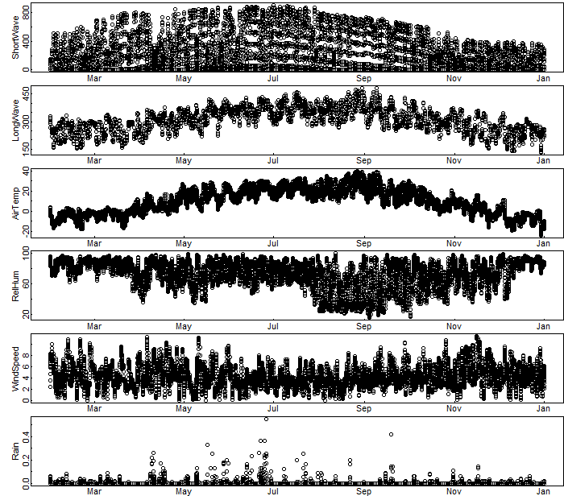

**Sunapee**

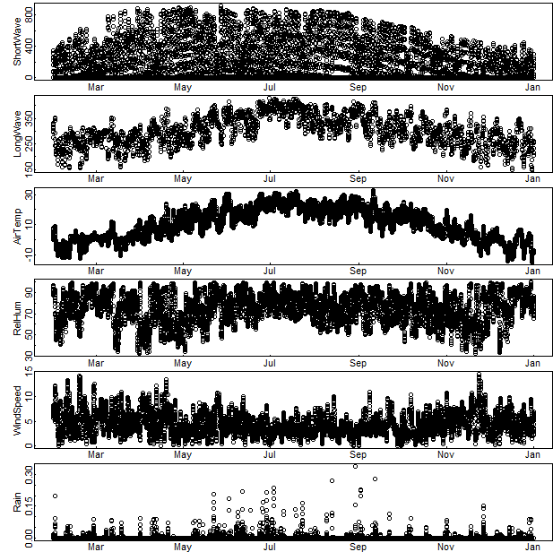

Objective 2: Temperature and chlorophyll-a heatmaps from GLM model output

Students should note differences in water temperature and chlorophyll-a with depth, and how that changes as the year progresses. Note that in spring, the lakes begin to stratify, with warmer water near the surface (epilimnion) and cooler water deeper (hypolimnion). Chlorophyll-a concentrations are highest during the late summer months (e.g., July, August).

**Note:** It is important when comparing plots for students to note the minimum and maximum values represented by the different colors! For example, on the chlorophyll-a plots, red = 10 ug/L in Sunapee, but 80 ug/L in Mendota!

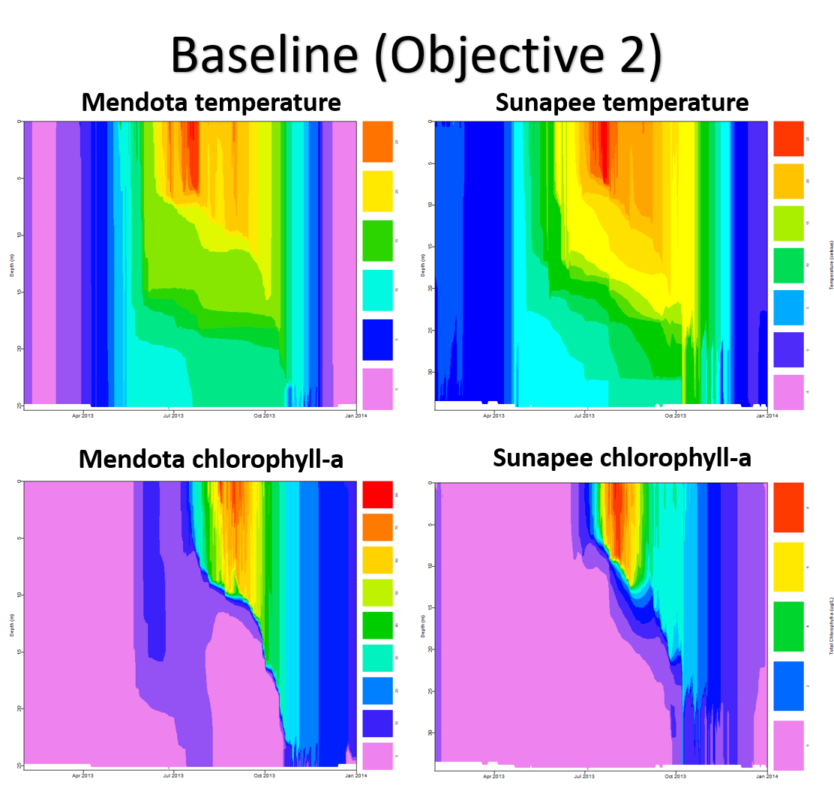

## Activity B

Objective 3: Select a climate change scenario

In looking at model outputs, the most important part is that students are able to explain: 1) How they predicted the change in climate would change lake thermal structure (their hypothesis), and 2) Whether the model output supported their hypothesis (and why they think it did/did not). We recommend that student pairs make a very brief presentation to the rest of the class, explaining these elements and sharing figures (e.g., heatmaps) from the model output that show how their lake changed. We encourage the instructor to ask questions of the students after their presentation, such as: “Did you expect that the lake would respond in this way to your climate scenario? Why or why not? What was surprising to you in this model output? Do you think that this scenario is realistic?” to stimulate discussion.

## Activity C

Objective 5: Select a land use scenario, then combine climate and land use scenarios to explore cross-scale interactions.

After running all four scenarios, students will produce line plots showing how the surface chlorophyll-a concentration changed across their four scenarios. Ask students whether their plot provides any evidence of cross-scale interactions, and why? I.e., is the combined effect of climate and land use easily predicted based on the individual climate and land use scenarios, or is the pattern different?

